MINUTE OF THE MANAGEMENT COMMITTEE MEETING
HELD ON 27 JUNE 2023
AT THE ASSOCIATION’S OFFICES & via ZOOM©

Present: Elaine Shaw
John Docherty
Jane McDonald
Jane Atkins
Arlene Martin
Kirsteen McLerie

In Attendance: Paul Immelman
Ikra Aziz

- APOLOGIES

Bobby Ward, John Barclay

- DECLARATION OF INTEREST

No declaration of interest.

- MINUTES OF PREVIOUS MEETING HELD 30 MAY 2023

The minutes of the previous meeting were approved on a proposal by Arlene Martin, seconded by Jane McDonald

4. MATTERS ARISING

No matters arising.

5. CORRESPONDENCE

5.1 Letter from EVH, notification of EVH Management Committee meeting
5.2 SHR ‘Our Regulation of Social Housing: a discussion paper
5.3 Putting Safety First, a joint briefing paper from SFHA, ALACHO & CIH

6. NOTES FROM OTHER MEETINGS

No note from other meetings.

7. CASH BALANCE AND PETTY CASH LIST – M 2023

The cheque and petty cash list for May 2023 was approved and signed by Elaine Shaw.

8. FINANCIAL STATEMENT 2023 to 31 MARCH – CHIENE+TAIT

Jeremy Chittleburgh from Chiene+Tait spoke to the previously distributed Financial Statements for the year ending 31st March 2023.

Jeremy confirmed that the financial statement of KCHA being accurate and devoid of error and
“give a true and fair view of the state of the Association's affairs as at 31 March 2023 and of its surplus for the year then ended;
• have been properly prepared in accordance with United Kingdom Generally Accepted Accounting Practice;
and
• have been prepared in accordance with the requirements of the
Co-operative and Community Benefits Societies Act 2014, the
• Housing (Scotland) Act 2014
• Determination of Accounting Requirements 2019”

The annual budget for 22/23 projected a surplus for the 12 months of around £399k
with net assets at £6.113m. Based on results to date, per the management accounts

Jeremy advised that there was no significant finds from the audit to draw to the Management Committee’s attention.

Following discussion, the Management Committee approved the annual accounts for the year 2022-23.

Management Letter and Representation letter were presented to the Management Committee for approval. After discussion, the Management letter was signed by Elaine Shaw. Jane Atkins and Kirsteen McLerie will sign letter at later date

9. DRUMCOG ARC COMPARISON

Paul presented to MC the Drumcog Annual Return on the Charter Comparison Report 2022-23

The figures are complied by Pineview Housing Association to use as benchmark for comparison and improving performance.

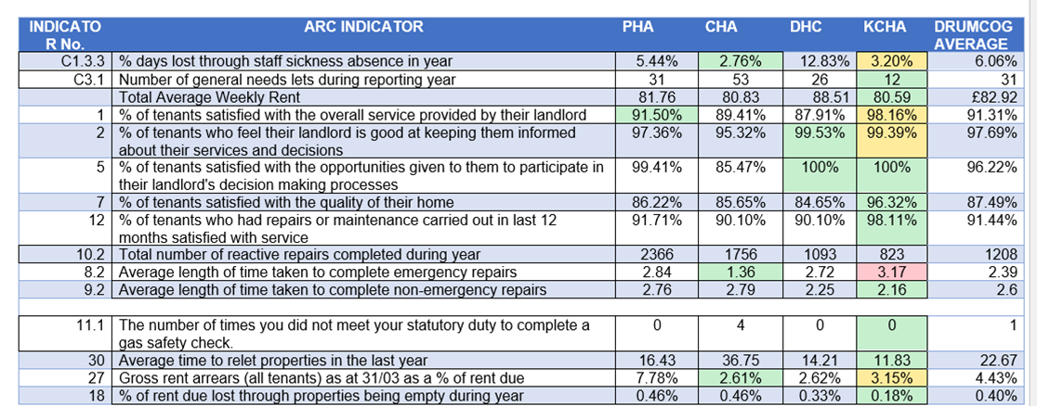

MC noted the above table that KCHA’s performance KCHA’s performance was better than the DRUMCOG averages in all aspects with one exception being response to emergency repairs, the figure was skewed due to one call out not attended to until the following day.

John commented that are great and will look even better over a national average.

10. WINDOW & DOOR REPLACEMENT – VERBAL UPDATE

Paul advised MC of the ongoing issues with the contractor Sovereign. The contract which commenced on the 28th May in Ladyloan 2 has yet to be completed.

There have been 18 defects and only 7 have been resolved. The communication from the contractor has been very poor and has made it incredibly difficult to resolve any defects quickly. There have been 2 occasions where Sovereign have advised they have been out to resolve the defects but have failed to attend.

Paul advised MC that a 7 day Letter has been sent to the contractor advising that these defects must attended immediately, failing to do this will result in the contractor not receiving the retention money and it will used by KCHA to repair all defects with another contractor.

Paul advised going the Association will be assessing the tender contractors on best quality as well as value for money. As competitive pricing does not always result in high standard of work.

11. KITCHEN REPLACEMENT – CLEDDANS COURT FINAL REPORT

Paul presented to MC the Kitchen renewal contract final report.

The kitchen renewal contract for Cleddans Court, comprised:

Fasque Place:- 17 Terraced houses &
9 Cottage flats
Ladyloan Place:-9 Terraced houses &
9 Cottage flats &
1 Wheelchair adapted flat, totalling 45 units.

One property was withdrawn from the contract at the tenant’s request, therefore a total of 43 kitchen replacements had been completed by the end of the contract.

The Wheelchair adapted flat was completed on 21st June 2023 as specialised parts had to be imported from Germany and there were delays to receiving the parts.

Following the completion of the contract, Tenant Satisfaction Forms were sent to all 43 tenants from which we received 10 respondents, 23.3%. The results of the survey were as follows:-

How would you rate the kitchen choice options offered by the Association? | Excellent | Very Good | Good | Average | Unsatisfactory | No Answer | TOTAL
 | 4 | 4 | 1 | 0 | 0 | 1 | 10
How would you rate the quality of the finished kitchen? | 5 | 4 | 1 | 0 | 0 | 0 | 10

 | YES | NO | COMMENT
Were you happy with the tradesmen who installed your kitchen | 10 | 0
Where the tradesmen polite and courteous | 10 | 0 | 1 comment – bad attitude from tiler
Did they leave your home in a clean and tidy condition | 10 | 0
Were you happy with the information provided to you prior to the contract commencing | 10 | 0

MC noted the that overall the contract performed well and completed on time.

12. ANNUAL ASSURANCE STATEMENT 2023 – EVIDENCE BANK

Paul presented the Annual Assurance Statement 2023.

MC members were made aware that it is a Regulatory requirement that all Registered Social Landlords (RSL’s) furnish the Scottish Housing Regulator (SHR) with an Annual Assurance Statement (AAS).

The AAS should be as succinct as possible, be no more than 2 pages of A4. The AAS should provide confirmation that the Association complies with the legislative and regulatory requirements.

The AAS should be completed and agreed by the MC. The MC should confirm that they
have appropriate assurance that the Association complies with

- all relevant regulatory requirements as set our in Chapter 3 of the Regulatory Framework
- all standards and outcomes in the Scottish Social Housing Charter
- all relevant legislative duties
- the Standards of Governance and Financial Management

The AAS should also set out any area(s) where the Association does not materially comply and must describe how the Association would plan to improve in those area(s)
and a timeframe for improvement.

The MC must confirm that they have seen and considered appropriate evidence to support the level of assurance

The MC must confirm the date of the meeting at which the Statement was considered and agreed.

The Chairperson should sign the AAS

The signed AAS must be submitted to the SHR no later than 31st October annually.

The MC are asked to consider the text of the AAS and approve it and thereafter to have one copy signed by the Chairperson for submission to the SHR.

The ongoing process for gathering and/or maintaining evidence to ensure the Management Committee has the necessary level of assurance it needs to complete the statement, is in many ways more important than the statement itself. Our self- assurance process is crucial to ensuring strong governance within our organisation, with regulatory compliance the side-effect of a robust process. It is this process that is the focus of this toolkit

Paul gave a summary of the current evidence bank and advised this will be updated once the regulator releases further guidance in July.

13. GOVERNANCE ACTION PLAN JUNE 2023

MC have confirmed that all reports and actions were complete or given outcomes.

MC approved the Governance Action plan June 2023

14. A.O.C.B

Paul advised a letter was received from Frank John the chair of New Hope Community North West Glasgow. Formerly known as the Drumchapel Asian Forum they have grown in both size and scope and now have an reach out to the northwest of Glasgow. As a result of this decided to rename the forum to be inclusive of people all over the Northwest of Glasgow and are registered as a SCIO with OSCR.

Due to the name change, they have had to create a new logo and as a result prepare new stationary and are looking for any charitable donation which can help cover the printing costs that amount to £560.00.

MC approved a donation of £50.00

Paul advised he will submit the charitable donation of £50.00

15. DATE OF NEXT MEETING

The next meeting will be an Operation Meeting to be held on Tuesday 25th
July 2023 at 5.45pm within the Association’s offices and via Zoom©.

